**Installation of VS Code:**

Steps to Download and Install Visual Studio Code on Windows 11:

1. Download the Installer:

- Go to the [Visual Studio Code website](https://code.visualstudio.com/).

- Click on the "Download for Windows" button.

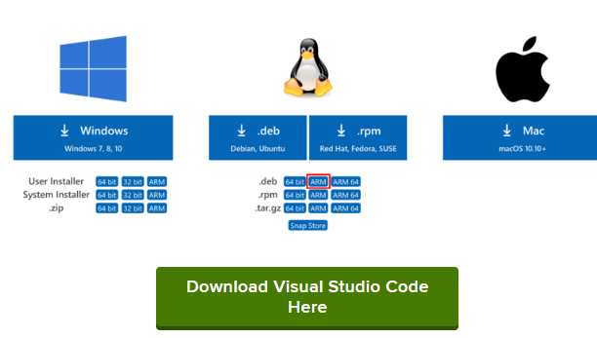

2. Run the Installer:

- Once the download is complete, open the downloaded `.exe` file.

- Follow the prompts in the setup wizard.

- Accept the license agreement and select the destination folder.

- Choose additional tasks, such as adding "Open with Code" to the context menu.

3. Finish Installation:

- Click the "Install" button.

- After installation, click "Finish" to launch VS Code.

**First-time Setup:**

Initial Configurations and Settings:

1. Install Extensions:

- Go to the Extensions view by clicking the Extensions icon in the Activity Bar or pressing `Ctrl+Shift+X`.

2. Configure Settings:

- Open the settings by clicking the gear icon in the lower-left corner and selecting "Settings" or pressing `Ctrl+,`.

- Important settings to configure:

- Editor: Font Size: Adjust to your preference for readability.

- Editor: Tab Size: Common settings are 2 or 4 spaces.

- Files: Auto Save: Set to "afterDelay" to automatically save files.

3. Theme and Appearance:

- Set the theme by going to "File" > "Preferences" > "Color Theme" or pressing `Ctrl+K Ctrl+T`.

- Popular themes include "Dark+" and "Monokai".

**User Interface Overview:**

1. Activity Bar:

- Located on the left side, it provides access to different views like Explorer, Search, Source Control, Run and Debug, and Extensions.

2. Side Bar:

- Displays different views based on the selected activity. For example, the Explorer view shows files and folders.

3. Editor Group:

- The main area where you edit files. You can open multiple files in tabs and split the editor to view files side-by-side.

4. Status Bar:

- Located at the bottom, it shows information about the current workspace, such as the branch name, encoding, and line endings.

**Common Tasks:**

- Opening files: Type `Open File` and select the file.

- Git commands: Type `Git: ` followed by the desired command.

- Changing settings: Type `Preferences: Open Settings`.

**Extensions in VS Code:**

Role of Extensions:

- Extensions enhance the functionality of VS Code by adding new features and capabilities.

Finding, Installing, and Managing Extensions:

1. Finding Extensions:

- Open the Extensions view (`Ctrl+Shift+X`).

- Search for extensions using keywords.

2. Installing Extensions:

- Click the "Install" button next to the desired extension.

Eg. Python.

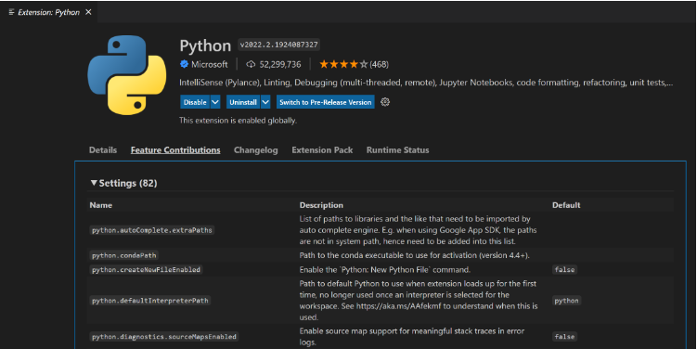

3. Managing Extensions:

- Manage installed extensions from the Extensions view. Enable, disable, or uninstall extensions as needed.

**Integrated Terminal:**

Opening and Using the Integrated Terminal:

- Open the terminal by selecting "View" > "Terminal" or pressing `Ctrl+``.

- You can run commands directly within the terminal, similar to an external terminal.

**File and Folder Management:**

Creating, Opening, and Managing Files and Folders:

1. Creating:

- Right-click in the Explorer view and select "New File" or "New Folder".

- Use the `Ctrl+N` shortcut to create a new file.

2. Opening:

- Double-click a file in the Explorer view.

- Use `Ctrl+O` to open a file dialog.

3. Navigating:

- Use `Ctrl+P` to quickly navigate to any file by typing its name.

- Use breadcrumbs in the editor to navigate through the folder hierarchy.

**Debugging in VS Code:**

Setting Up and Starting Debugging:

1. Configure Launch Configuration:

- Go to the Run and Debug view (`Ctrl+Shift+D`).

- Click "create a launch.json file" to configure the debugger.

2. Starting Debugging:

- Set breakpoints by clicking in the gutter next to the line numbers.

- Press `F5` to start debugging.

**Integrating Git with VS Code:**

1. Initialize a Repository:

- Open the Source Control view (`Ctrl+Shift+G`).

- Click "Initialize Repository".

2. Making Commits:

- Stage changes by clicking the "+" icon.

- Enter a commit message and click the checkmark icon.

3. Pushing Changes to GitHub:

- Click the "..." menu in the Source Control view and select "Push".

- Authenticate with GitHub if required.

References:

- [Visual Studio Code Documentation](https://code.visualstudio.com/docs)

- [Getting Started with Visual Studio Code](https://code.visualstudio.com/docs/introvideos/basics)